*LAB # 07*

behavioral patterns: chain of responsibility pattern & command pattern

# *OBJECTIVE:*

*Understand behavioral design patterns: Chain of responsibility Pattern and Command Pattern.*

***CHAIN PATTERN:***

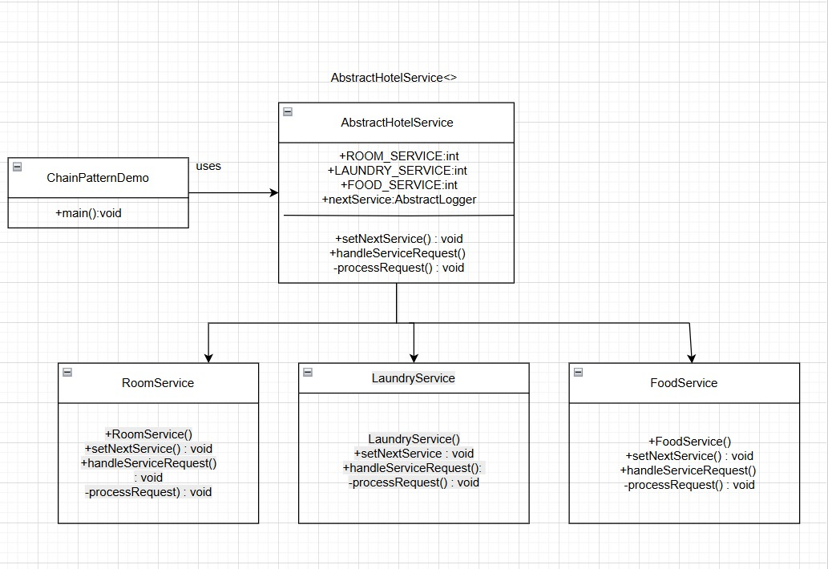

***JAVA CODE:***

***Step 1: Create the abstract handler (AbstractHotelService.java)***

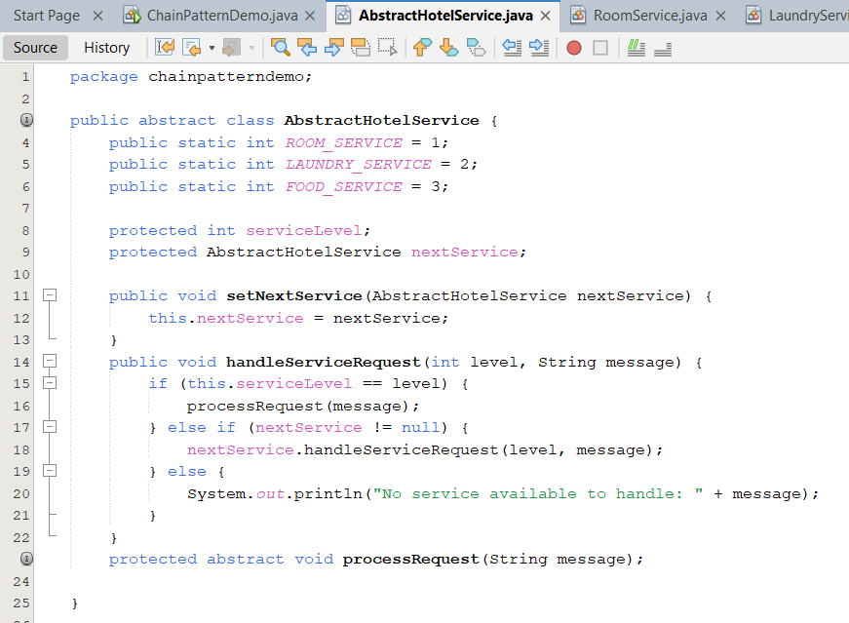

***Step 2: Create concrete service classes***

***RoomService.java***

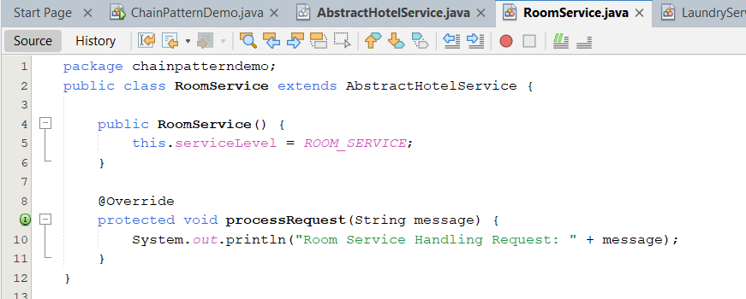

***LaundryService.java***

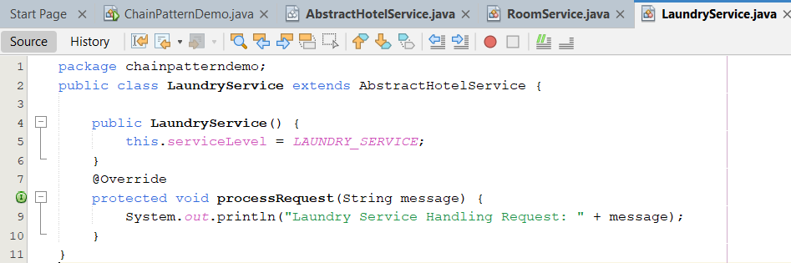

***FoodService.java***

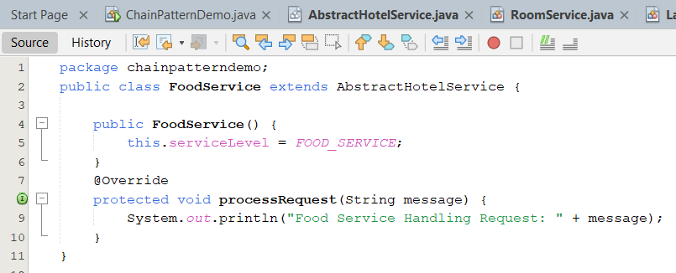

***Step 3: Demo Class to set the chain and test requests***

***ChainPatternDemo.java***

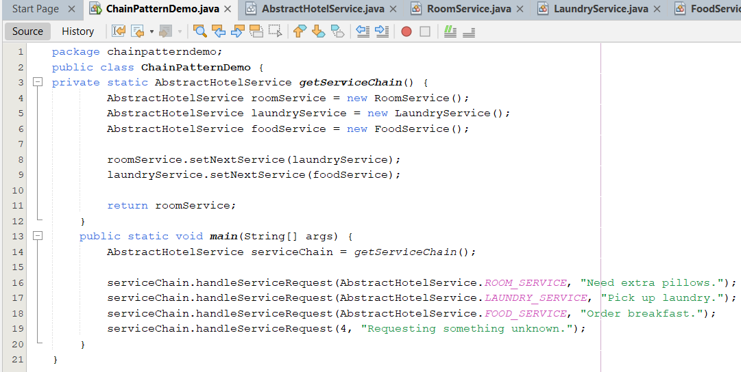

***OUTPUT:***

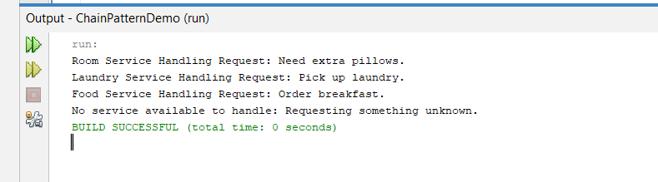

***COMMAND PATTERN:***